WESLEYAN COLLEGE
Chief of Police DEPARTMENT OF CAMPUS POLICE 4760 Forsyth Road Lionel Doss Macon, Georgia 31210
Phone: (478) 757-2038

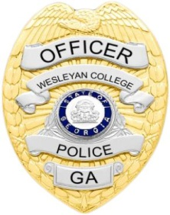
__________________________________________________________________________

October, November, December 2016

October November December
Murder……………………………….. 0 0 0
Robbery……………………………… 0 0 0
Forcible Sex Offenses……………... 0 0 0
Non-Forcible Sex Offenses……….. 0 0 0
Aggravated Assaults………………. 0 0 0
Burglary……………………………… 0 0 0
Theft by Taking……………………… 0 1 0
Liquor Law Violation……………….. 0 0 0
Drug Offenses………………………. 0 0 0
Entering Auto………………………… 0 0 0
Weapons Possession………………. 0 0 0
Theft by Taking (auto)……………… 0 0 0
Criminal Trespass…………………… 0 0 0
Sexual Assault 0 0 0
Stalking 0 0 0
Domestic Violence 0 0 0

Fire Alarm…………………….. 2 2 3
Fire 0 0 1

